Name: Pratik Jasani

Course: EN605.645

**Regression Self Check**

**Θ = [1.3, 2.9]**

**Datapoints = [1.0, 2.0]**

**[3.0, 1.0]**

**1. Draw => 1.3 + 2.9x**

**2. For each data point, calculate y hat.**

y_hat_1 = 1.3 + 2.9(1.0) = 4.2

y_hat_2 = 1.3 + 2.9(3.0) = 10

**3. For each data point, draw point—both the real location and the estimated location**.

Green – original points

Blue – estimated points

Red – original line (1.3 + 2.9x)

**4. Calculate the error for this data set (mean squared error).**

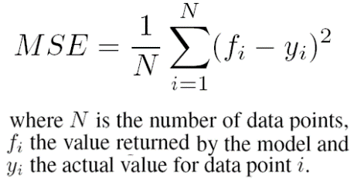 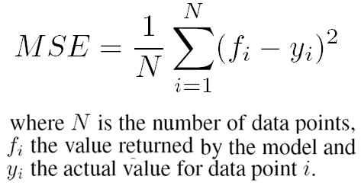

MSE = (1/2) * [ (4.2 – 2.0) + (10-1.0) ] = 5.6

**5. Using the Module 8 pseudocode, calculate one adjustment to the thetas, assuming alpha = 0.1**

Θ1 = Θ1 –alpha*MSE => 1.3 – 0.1*5.6 = 0.74

Θ2 = Θ2 –aplpha*(1/2) * [ (4.2 – 2.0)*1.0 + (10-1.0)*3.0 ] => 2.9 – 0.1*0.5*29 = 1.45

**6. Draw the new line (thetas).**

**7. Draw the new estimates (y-hats).**

Y_hat_1 = 0.74 +1.45*1.0 = 2.10

Y_hat_2 = 0.74 + 1.45 * 3.0 = 5.00

Green – original points

Blue – estimated points

Red – original line (1.3 + 2.9x)

Purple – new estimated line (0.74 + 1.45x)

Black – new estimated values

MSE = (1/2) * [ (2.10 – 2.0) + (5-1.0) ] = 2.05

New thetas :

Θ1 = Θ1 –alpha*MSE => 0.74 – 0.1*2.05 = 0.535

Θ2 = Θ2 –alpha*(1/2) * [ (2.10 – 2.0)*1.0 + (5-1.0)*3.0 ] => 1.45 – 0.1*0.5*12.1 = 0.845

Y_hat_1 = 1.35, y_hat_2 = 2.99

Green Points – original points

Blue – estimated points

Red – original line (1.3 + 2.9x)

Purple – new estimated line (0.74 + 1.45x) (first estimation)

Black – new estimated values

Green Line – new estimated theta(2nd estimation)

MSE = (1/2) * [ (1.35– 2.0) + (2.99-1.0) ] = 0.671

New thetas :

Θ1 = Θ1 –alpha*MSE => 0.535 – 0.1*0.671 = 0.4608

Θ2 = Θ2 –alpha*(1/2) * [ (1.35 – 2.0)*1.0 + (2.99-1.0)*3.0 ] => 0.845 – 0.1*0.5*12.1 = 0.5553

Green Points – original points

Red – original line (1.3 + 2.9x)

Purple – new estimated line (0.74 + 1.45x) (first estimation)

Green Line – new estimated theta(2nd estimation)

Black Line – new estimated theta (3rd estimation)

MSE = 0.07159999999999989

Y_hat1 = 1.0162

Y_hat2 = 2.127

New thetas = [0.45364000000000004, 0.4355399999999999]

Red line above black line - 4th estimation

MSE = -0.1752800000000001

**Logistics Regression**

Θ = [0.8, 1.1], Data = [[1.1, 0], [2.7,1]]

**1. Draw an approximation of the logistic curve represented by these parameters by plotting the values for x_1 = {-3, -2, -1, 0, 1, 2, 3}.+**



Where m = 1.1, b= 0.8, x = x_1



**2. Calculate the error (log loss) for this data set.**

loss = -0.5 * [(0 * log(0.88) + (1-0) * log(1-.88) + (1 * log(0.977) + (1-1) * log(1-.977)] =

-0.5 * [-0.920818754 + -0.0101054363] = 0.465462095

**3. Plot these actual points (x_1, y) and estimated points (x_1, y_hat).**

Y_hat_1 = 1 / (1+ e^(1.1 * 1.1 + 0.8)) = 0.881843022191

Y_hat_2 = 1 / (1+ e^(1.1 * 2.7 + 0.8)) = 0.977467360544

Black points – y_hat

Blue points – original datapoints

**4. Using the pseudocode provided, calculate one adjustment to the thetas, assuming alpha = 0.1**

Θ0 = 0.8+ 0.1 * 0.5 * [(0.88-0) + (0.977 – 1)] = 0.84285

Θ1 = 1.1+ 0.1 * 0.5 * [(0.88 - 0)*1.1 + (0.977 - 1)*2.7] = 1.145295

Y_hat_1 = 1 / (1+ e^(1.145 * 1.1 + 0.84)) = 0.890886654607

Y_hat_2 = 1 / (1+ e^(1.145 * 2.7 + 0.84)) = 0.980778364268

Loss = -0.5 * [(1.1 * log(0.891) + (1-1.1) * log(1-.891) + (2.7 * log(0.9807) + (1-2.7) * log(1-.9807)]

= -0.5 * [0.041 + 2.892] = -1.4665

Θ0 = 0.843+ 0.1 * 0.5 * [(0.891-0) + (0.981 – 1)] = 0.8866

Θ1 = 1.145+ 0.1 * 0.5 * [(0.891 - 0)*1.1 + (0.981 - 1)*2.7] = 1.19144

Follow the rest of the process the same way.